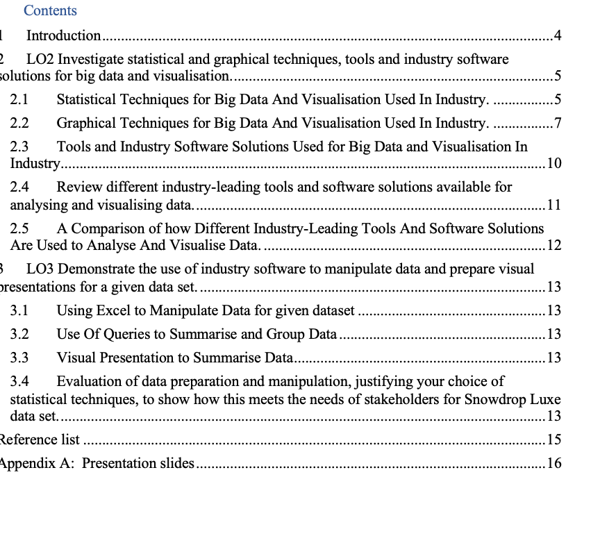

# 

# Introduction

This report will examine statistical and graphical techniques and tool of software solutions for big data and visualisation for industries.

It will demonstrate the use of industrial software to manipulate big data and visual presentations for the data of Celima Luxe

Will also include a presentation that include:

* The fundamental concepts of big data
* The value of data for decision making to users and organisations.
* The advantages and challenges of data driven.
* The potential impact of data on users and organisations for decision making.
* The roles, responsibilities, and challenges of data specialist
* Strategies used by data specialist to ensure data compliance.
* The role, responsibilities and challenges of data specialist when building ethics into data driven culture.

# LO2 Investigate statistical and graphical techniques, tools and industry software solutions for big data and visualisation.

## Statistical Techniques for Big Data and Visualisation Used In Industry.

There are two types of Statistics:

* **Descriptive**: Is a subfield of statistics that deals with the meaningful summarization and presentation of data. A dataset's key characteristics are intended to be described and summarised, giving information about its primary patterns, variability, and distributions. Measures like mean, median, mode, standard deviation, range, and frequency distributions are examples of common descriptive statistics. These statistics aid in comprehending the data's features and provide the framework for further investigation and decision-making.
* **Inferential Statistics:** is a subfield of statistics that deals with inferring information about a population from a sample of data. It makes inferences about a bigger group based on the observable features of the sample using probability and sampling procedures. Inferential statistics aids researchers and analysts in making generalisations, testing hypotheses, and estimating parameters for a larger population by analysing sample data.

**DESCRIPTIVE STATISTICS**

1. **Measure of central tendency** is used to describe statistical measurements that show the typical or core value of a dataset. There are four standard methods for calculating central tendency:
   * + **Mean:** The dataset's values are added up to determine the mean, which is then divided by the total number of data points. It is susceptible to extreme values and depicts the dataset's average value, making it less resistant to outliers.
     + **Median:** The middle value in a sorted dataset is called the median. The value is what divides the data into the higher and lower halves. When dealing with skewed distributions, median is frequently favoured over mean since it is less susceptible to outliers.
     + **Mode:** The most prevalent value in the dataset is represented by the mode. One mode (unimodal), two modes (bimodal), or more modes (multimodal) can be present in a dataset. For categorical data and discrete variables, mode is useful.
     + **Skewness:** Skewness quantifies the asymmetry in the distribution of a dataset. A longer tail on the right side of the distribution is indicated by positive skewness, whereas a longer tail on the left is indicated by negative skewness. The skewness value of a symmetrical distribution is almost 0.
2. **Measure of frequency** is a term used to describe statistical metrics that show the frequency or count of particular values or events in a dataset. One typical frequency measurement is:
   * + **Count**: is an easy calculation that shows the frequency with which a specific value or event arises in the collection. It is the overall sum of all instances of a particular data point. For categorical or discrete data, count is especially useful for determining the frequency of individual data points or categories within a dataset.
3. **Measure of position** refers to statistical measures that reveal the position or standing of a particular value in relation to other values within a dataset. There are two typical positional indicators:
   * + Percentile: A percentile value is the percentage of data points in a dataset that fall under a given number. For instance, the first quartile, or 25th percentile, indicates the value below which 25% of the data points fall. The value that divides the dataset into two equal halves is represented by the 50th percentile, which is sometimes referred to as the median. Data distribution may be understood and outliers or extreme values can be found using percentiles.
     + Quartile: The precise percentiles known as quartiles are used to divide a dataset into four equal portions. The 25th percentile is represented by the first quartile (Q1), the median is represented by the second quartile (Q2), and the 75th percentile is represented by the third quartile (Q3). When summarising the distribution of data and evaluating the central tendency of distributions, quartiles are especially helpful.

**INFERENTIAL STATISTICS**

1. **Normal Distribution**: Due to its popularity as one of the most common probability distributions, the normal distribution plays a significant part. The Gaussian distribution is another name for it. The mean (average) is located in the centre of the bell-shaped normal distribution, and a certain standard deviation determines how widely the data are spread out.
2. **Confidence Intervals**: A key idea in inferential statistics is the concept of confidence intervals. They offer a method for estimating an unidentified population parameter (such the population mean or proportion) using a sample of the population. A confidence interval is a range of values derived from sample data that, with a certain degree of certainty, contains the true value of the population parameter.

## Graphical Techniques for Big Data And Visualisation Used In Industry.

The creation of graphical representations of data is referred to as data visualisation. This process helps the presenter make their points clear so that the audience can readily comprehend them and draw their own conclusions.

You can use a variety of tools and strategies to visualise data, so you should be aware of when to utilise each one. The most crucial data visualisation methods that any professional should be aware of are listed below. (Business Insights Blog, 2019)

* **Pie Chart**: Pie charts are used in a wide range of applications since they are one of the most widely used and fundamental data presentation techniques. Pie charts are very useful for showing proportions or comparing different pieces of an item to the whole.

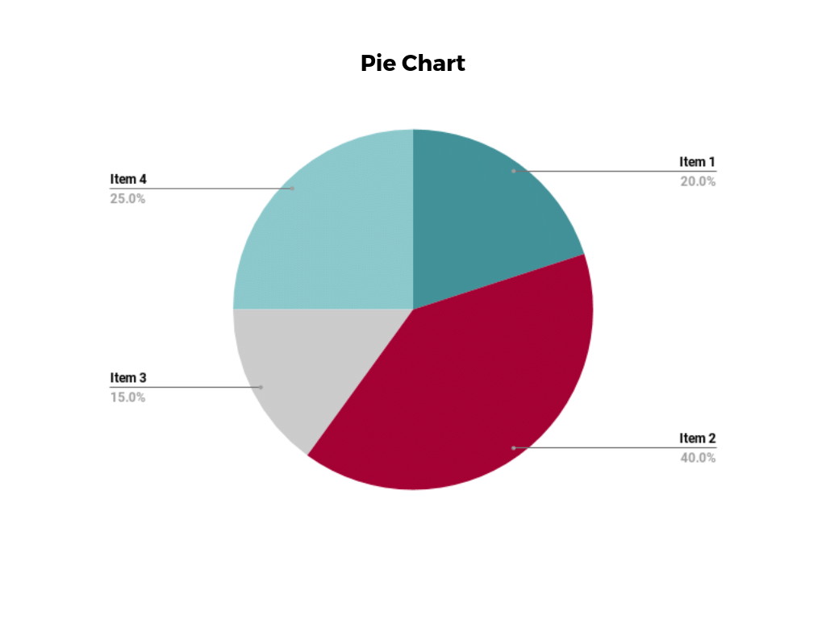

* **Bar Chart**: Traditional bar charts, also referred to as bar graphs, are a common and straightforward method for visualising data. This type of visual representation places the categories that are being compared on one axis of the chart and a measured value on the other. The length of the bar displays the performance of each group in respect to the value.

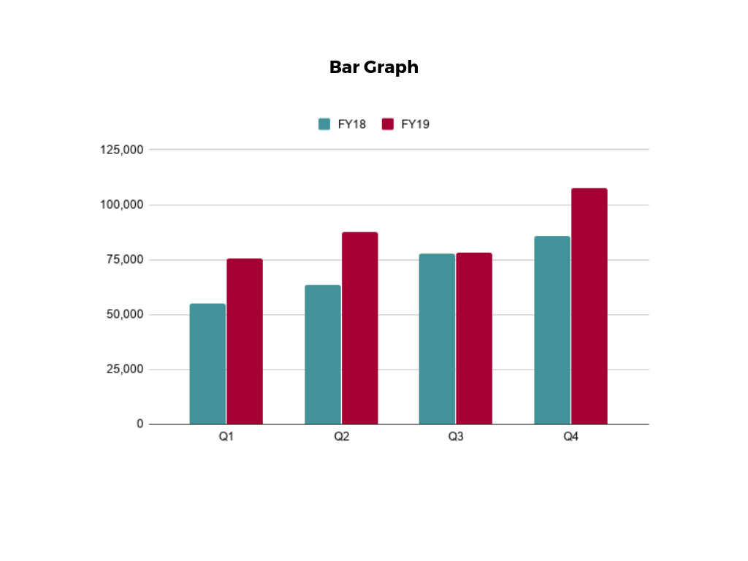

* **Histogram**: Histograms show how data is distributed over a continuous range or a specific period, in contrast to bar charts. These visualisations are useful for locating gaps, outlier values, and areas of value concentration.

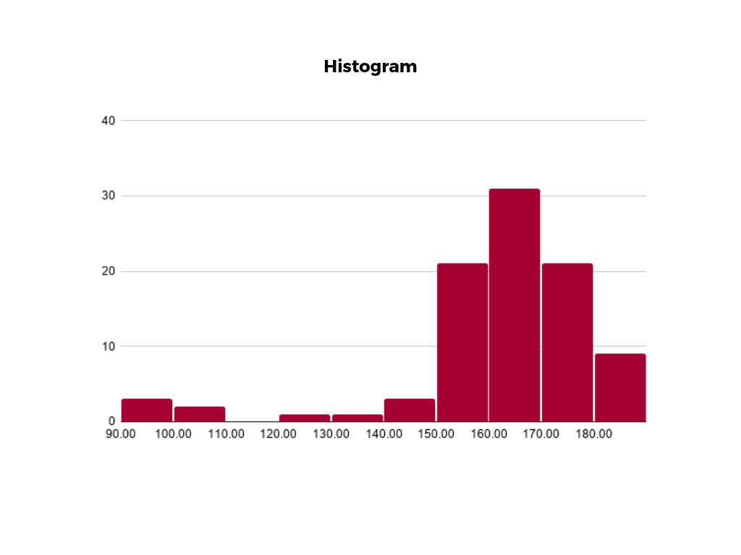

* **Gantt Chart**: In project management, Gantt charts are especially well-liked because they are useful for showing a project's timeline or the progression of work. The horizontal axis of this type of chart indicates the time intervals, while the vertical axis lists the tasks that must be accomplished. The horizontal bars in the chart's body indicate how long each action lasted.

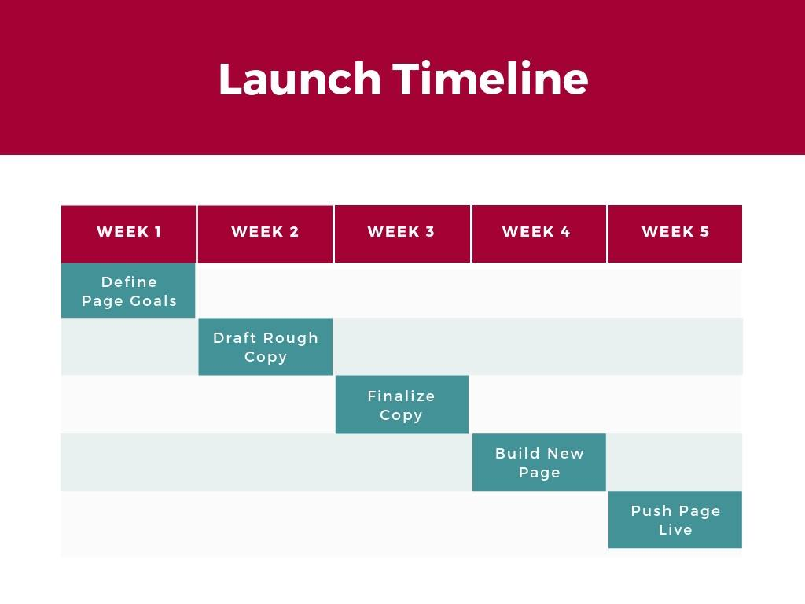

* **Area Chart**: The total value of each data point is represented by a shaded area beneath the line in an area chart, also called an area graph. When comparing various data series on the same graph, stacked area charts are utilised. 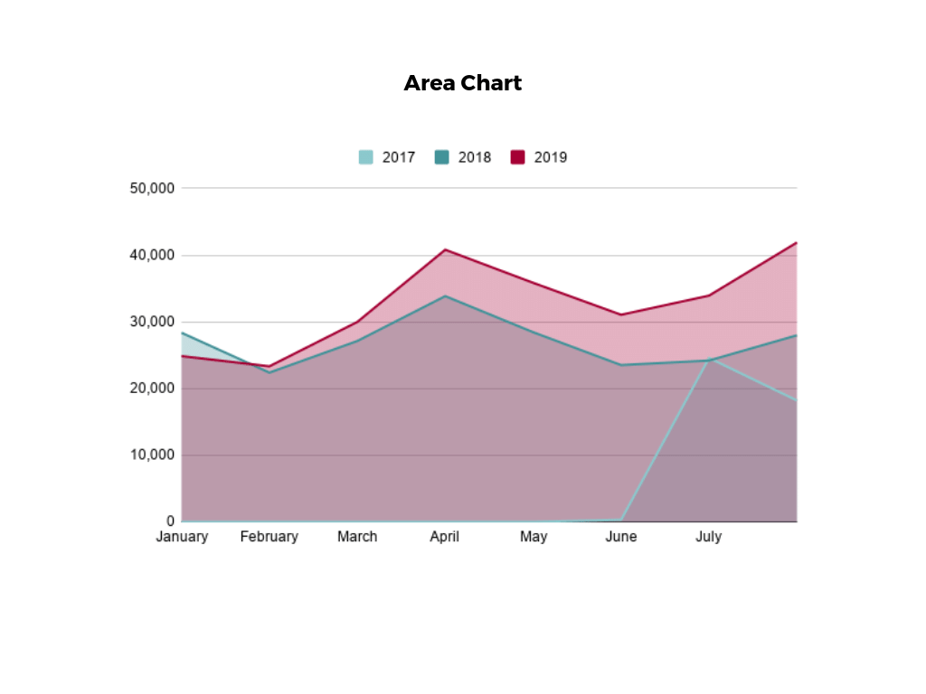

## Tools and Industry Software Solutions Used for Big Data and Visualisation In Industry.

Numerous tools and commercial software programmes are frequently used in the big data and visualisation fields to handle, examine, and present enormous volumes of data. With these tools, you can handle large amounts of data effectively and produce meaningful visualisations. Some of the most popular equipment and software programmes in use today in business are listed below:

1. Tableau
2. Power BI
3. Python (with Matplotlib and Seaborn)
4. Google Data Studio

## Review different industry-leading tools and software solutions available for analysing and visualising data.

* 1. **Tableau**: Tableau is a renowned data visualisation application that is used extensively across a variety of sectors. Both technically savvy users and non-technical people may use it thanks to its intuitive UI and drag-and-drop capabilities. Databases, spreadsheets, and cloud computing platforms are just a few of the data sources that Tableau can integrate with without any issues. Advanced analytics capabilities, dynamic dashboards, and a variety of visualisation options are all provided by the programme. It is a top choice for data analysts, business intelligence experts, and decision-makers due to its capacity to manage huge data and produce aesthetically stunning visualisations.
  2. **Power BI**: Power BI, a robust data visualisation tool created by Microsoft, effortlessly integrates with other Microsoft products to give customers a comfortable experience. It provides interactive dashboards, reports, and tools for data exploration. With the help of Power BI's natural language querying functionality, users can build insights using short sentences and connect to a range of data sources. Power BI makes it simple for teams to collaborate and share insights thanks to its powerful sharing and collaboration tools.
  3. **Python**: Python is a versatile alternative for producing static and interactive visualisations, together with data visualisation packages like Matplotlib and Seaborn. Python is a popular option for data analysts and scientists because of its skills for manipulating data and its visualisation packages. Python is a flexible tool for data analysis and visualisation because to its simplicity of use and the availability of extra modules for different uses.
  4. **Google Data Studio:** Using data from many sources, such as Google Analytics and Google Sheets, users may generate customizable and shareable reports and dashboards using the free and user-friendly Google Data Studio application. It is a fantastic option for businesses who depend significantly on Google products and want a cloud-based solution.

## A Comparison of how Different Industry-Leading Tools And Software Solutions Are Used to Analyse And Visualise Data.

Here is a comparison of the features and capabilities of Excel, Tableau, and Python Matplotlib for data analysis and visualisation:

**EXCEL VS TABLEAU**

|  |  |
| --- | --- |
| **Excel** | **Tableau** |
| Is a widely used spreadsheet software that offers basic data analysis and visualization capabilities. | Tableau is a dedicated data visualization tool designed to handle large datasets and create interactive and dynamic visualizations. |
| It is user-friendly and familiar to many users, making it accessible for data manipulation and simple charting. | It provides a wide range of visualization options, including charts, graphs, maps, and dashboards, allowing for in-depth exploration of data. |
| Excel's functionalities are limited compared to Tableau, especially for handling large datasets and creating complex visualizations. | Tableau's drag-and-drop interface and powerful analytics capabilities make it an ideal choice for data analysts and business intelligence professionals. |
| While Excel is suitable for small-scale data analysis and simple charts, it may become cumbersome and less efficient when dealing with big data or requiring advanced visualizations. | It excels in real-time data visualization and offers advanced features like data blending and storytelling. |

**EXCEL VS PYTHON MATPLOTLIB**

|  |  |
| --- | --- |
| **Excel** | **Python Matplotlib** |
| Excel is a spreadsheet software that offers basic charting and graphing capabilities for data visualization. | Matplotlib is a powerful data visualization library in Python that offers extensive customization and control over plot aesthetics. |
| It is user-friendly and familiar, making it accessible to a wide range of users. | It is well-suited for creating static, high-quality visualizations for various data types and structures. |
| Excel is suitable for quick and simple data visualization tasks, especially for small datasets. | Matplotlib's flexibility allows users to create sophisticated and customized visualizations, but it requires more coding and data manipulation skills compared to Excel. |
| it may not be the best choice for more complex visualizations or handling big data. |  |

**TABLEAU VS PYTHON MATPLOTLIB**

|  |  |
| --- | --- |
| **Tableau** | **Python Matplotlib** |
| Tableau is a dedicated data visualization tool with a user-friendly interface and powerful analytics capabilities. | Matplotlib is a versatile data visualization library in Python, offering extensive customization and control over plot aesthetics |
| It excels in handling large datasets and creating interactive and dynamic visualizations, including dashboards and storytelling | It is well-suited for creating static, high-quality visualizations for various data types and structures. |
|  | Matplotlib is commonly used in data analysis, scientific research, and data-driven projects. |

# LO3 Demonstrate the use of industry software to manipulate data and prepare visual presentations for a given data set.

## Using Tableau to Manipulate Data for given dataset.

Tableau is a powerful data visualization and business intelligence tool that allows you to manipulate, analyse, and visualize data in a user-friendly and interactive way. Here are some reasons why you might choose to use Tableau to manipulate data:

* **User-Friendly Interface**: Tableau provides an intuitive drag-and-drop interface that makes it easy to create complex visualizations and perform data manipulation tasks without requiring extensive coding or technical skills.
* **Data Integration**: Tableau can connect to a wide variety of data sources, including databases, spreadsheets, cloud services, and more. This allows you to bring together data from different sources and manipulate it all within a single platform.
* **Data Transformation**: Tableau allows you to transform, clean, and reshape your data using built-in tools. You can perform tasks like filtering, sorting, grouping, and creating calculated fields to prepare your data for analysis.
* **Interactive Visualizations**: One of Tableau's strengths is its ability to create interactive and dynamic visualizations. You can build dashboards and reports that allow users to explore data, filter information, and gain insights through visual exploration.
* **Quick Insights**: With Tableau's instant visual feedback, you can quickly identify patterns, trends, and outliers in your data, helping you make informed decisions.
* **Real-Time Analytics:** Tableau supports real-time data connections, allowing you to analyse and visualize data that is constantly being updated, which is crucial for businesses that need to make decisions based on current information.
* **Scalability:** Tableau can handle large datasets and complex queries efficiently, making it suitable for organizations with varying sizes of data.
* **Data Collaboration:** Tableau enables collaborative work on data projects. You can share your dashboards and reports with others, and even embed them in websites or presentations.
* **Predictive Analytics**: While not as advanced as specialized predictive analytics tools, Tableau does provide some level of predictive modelling and forecasting capabilities that can be useful for initial analysis.
* **Storytelling**: Tableau allows you to create data-driven stories, combining visualizations and insights into a cohesive narrative that helps convey your findings effectively to others.
* **Customization:** Tableau offers a wide range of customization options for your visualizations, enabling you to tailor the appearance and behaviour of your dashboards to suit your specific needs.
* **Cross-Device Compatibility**: Tableau visualizations can be accessed and interacted with on various devices, including desktops, tablets, and smartphones**.**

## Use Of Queries to Summarise and Group Data

In this chart has been used count of age to see the total of ages in different locations

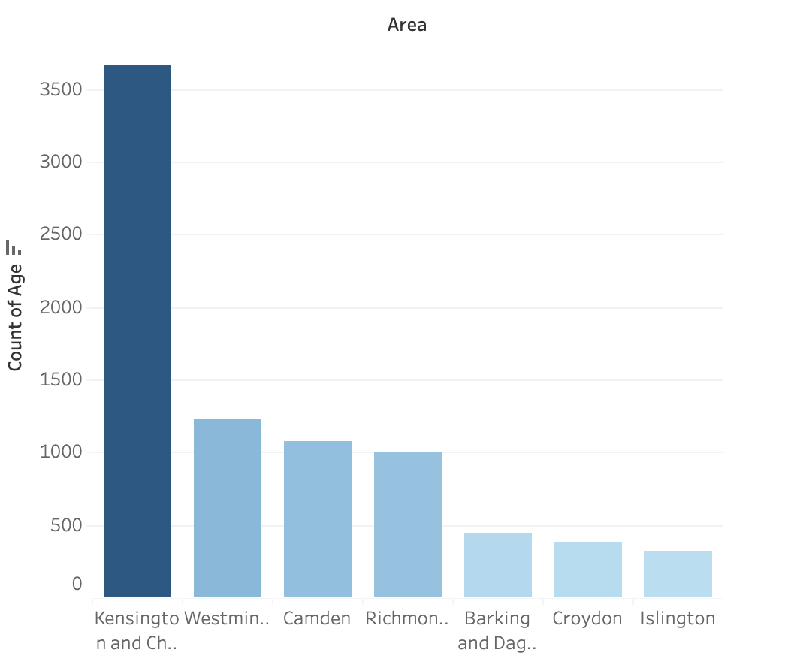

In this chart has been used the sum of capital gain to see the total of capital in different locations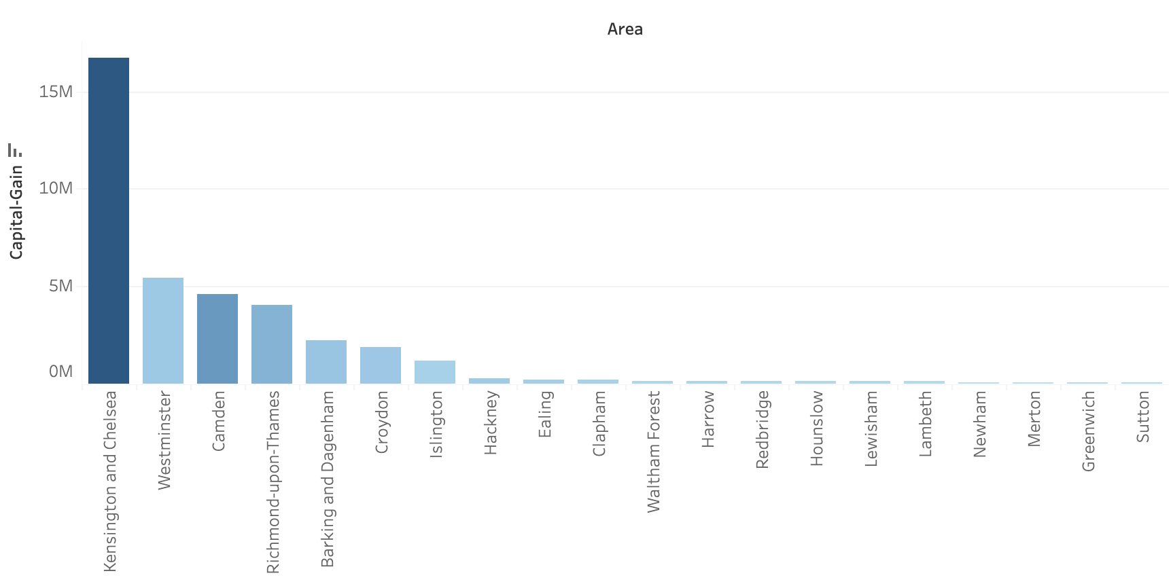

## 

## Visual Presentation to Summarise Data

These are the steps to create a dashboard in Tableau:

1. **Build Worksheets:** Create individual worksheets with the visualizations you want to include in the dashboard.
2. **Open Dashboard Pane:** Click on the "Dashboard" tab at the bottom of the screen to open the dashboard pane.
3. **Drag Worksheets:** Drag the worksheets you created onto the dashboard pane.
4. **Arrange and Resize:** Arrange and resize the worksheets within the dashboard pane to create your desired layout.
5. **Add Objects:** Add objects like text, images, and web pages to enhance your dashboard's context.
6. **Apply Filters:** Add filters that affect multiple worksheets to create interactive filtering.
7. **Create Actions (Optional):** Set up actions that enable interactions between different parts of the dashboard.
8. **Format and Style:** Apply formatting and styling to the dashboard to make it visually appealing.
9. **Preview and Interact:** Use the "Show Dashboard" button to preview and interact with your dashboard.
10. **Save and Share:** Save your dashboard and share it with others for viewing and analysis.

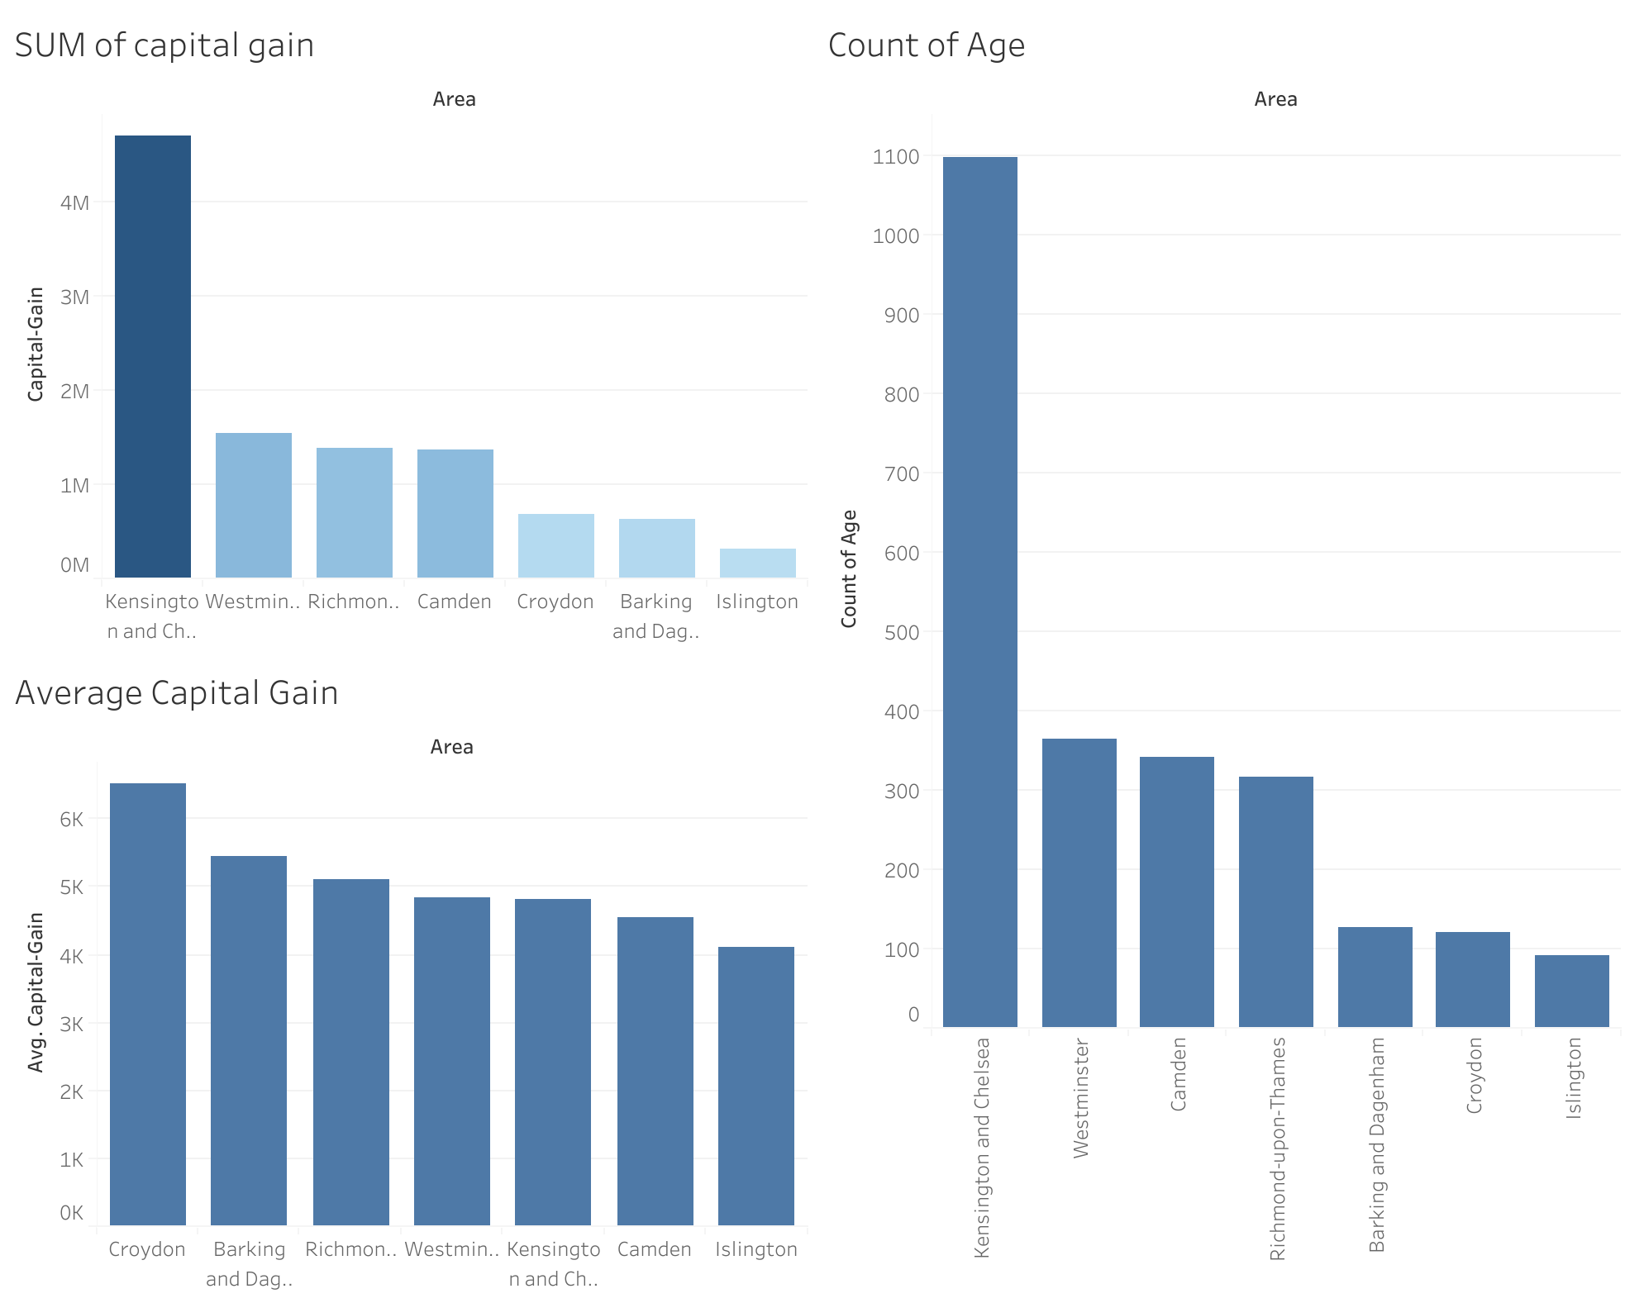

## Evaluation of data preparation and manipulation, justifying your choice of statistical techniques, to show how this meets the needs of stakeholders for Celima Luxe data set.

To clean data in Tableau:

1. **Connect to Data:** Open Tableau, connect to your data source (e.g., Excel, database), and load the data.
2. **Identify Issues:** Review the data for missing values, duplicates, outliers, and inconsistencies.
3. **Handle Missing Values:** Use the "Data" menu to handle missing values. You can filter out, replace, or impute missing data.
4. **Remove Duplicates:** In the "Data" menu, choose "Remove Duplicates" to eliminate duplicated rows.
5. **Correct Inconsistencies:** Use calculated fields to correct inconsistent data or apply transformations.
6. **Filter Irrelevant Data:** Apply filters to remove unnecessary data that won't contribute to your analysis.
7. **Aggregate if Needed:** If dealing with granular data, aggregate to a higher level for meaningful insights.
8. **Create Calculated Fields:** Generate new fields using calculated fields for necessary transformations.
9. **Preview and Validate:** Check your data after cleaning to ensure accuracy.
10. **Save and Use:** Save the cleaned data for analysis and visualization.

Using **COUNT** on big data helps understand data volume, identify data quality issues, perform basic data profiling, and assist in resource planning and query optimization. It also aids in sampling, aggregations, and monitoring, providing foundational insights and aiding in decision-making.

Based on the requirements of the client the filters that need to be used are:

* Male
* Over 50 years.
* Over 50K per year
* Area

From the data that we work with we have 2 types:

* **Numerical:** The representation of numbers in numerical data allows for the execution of mathematical operations. The use of numerical data in calculations, statistical analysis, and modelling is quite frequent. Arithmetic operations like addition, subtraction, multiplication, and division can be used to manipulate it.
* **String:** Character data, commonly referred to as string data, is a representation of character sequences. Letters, numbers, symbols, spaces, and more are all acceptable character types. Text-based data is represented using strings. For storing textual information like names, locations, descriptions, and more, string data is frequently employed.

Based on the charts my recommendation for the organisation is to locate the first physical store in Kensington and Chelsea because is the place where all the requirements have better numbers

# 

# Reference list

Emerald Publishing. (2023). *Choose the right statistical technique*. [online] Available at: https://www.emeraldgrouppublishing.com/how-to/research/data-analysis/choose-right-statistical-technique [Accessed 27 Mar. 2023].

Great Learning Team (2020). *Understanding Data Visualization Techniques*. [online] Great Learning Blog: Free Resources what Matters to shape your Career! Available at: https://www.mygreatlearning.com/blog/understanding-data-visualization-techniques [Accessed 27 Mar. 2023].

Investopedia. (2023). *Descriptive Statistics: Definition, Overview, Types, Example*. [online] Available at: https://www.investopedia.com/terms/d/descriptive_statistics.asp [Accessed 27 Mar. 2023].

Statistics How To. (2023). *Inferential Statistics: Definition, Uses*. [online] Available at: https://www.statisticshowto.com/probability-and-statistics/statistics-definitions/inferential-statistics/ [Accessed 27 Mar. 2023].

Wang, C., Chen, M.-H., Schifano, E., Wu, J. and Yan, J. (2016). Statistical methods and computing for big data. *Statistics and Its Interface*, [online] 9(4), pp.399–414. doi: https://doi.org/10.4310/sii.2016.v9.n4.a1.

‌

‌

# Appendix A: Presentation slides

 